**User Manual**

The user manual of “**ONLINE GIFT ORDER SYSTEM**”

The interface consists of the following pages.

* **Home Page**

Home page contains link to the customer login, registration, products, sellers, staff login panel and shop owner login panel.

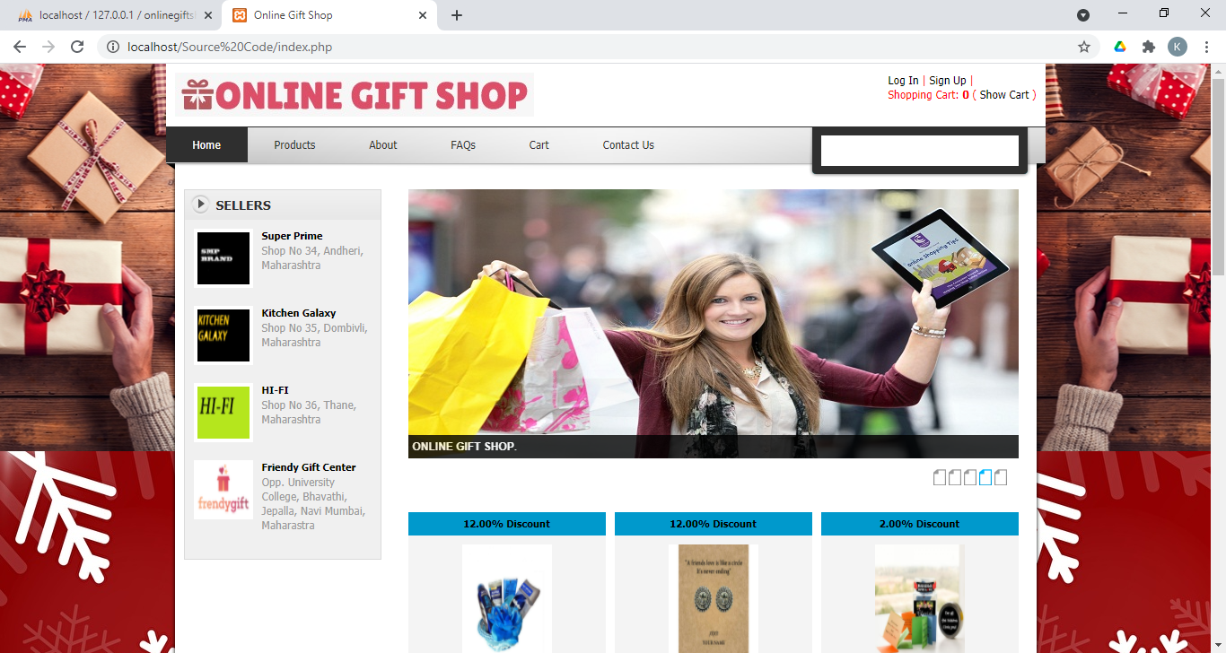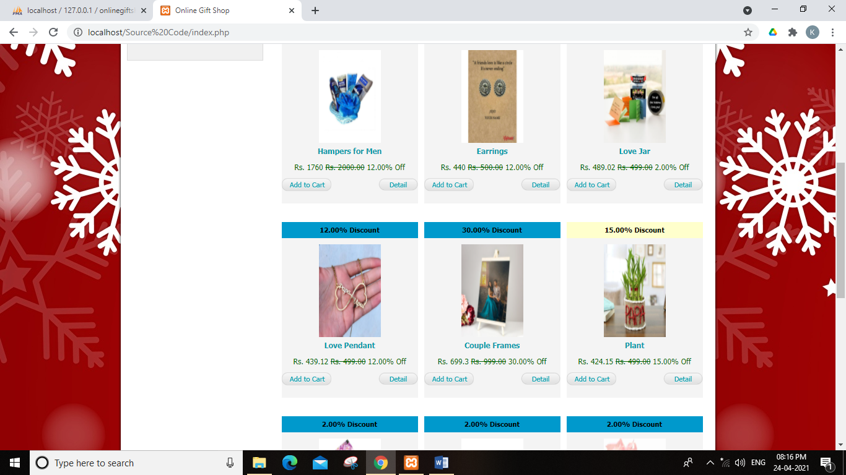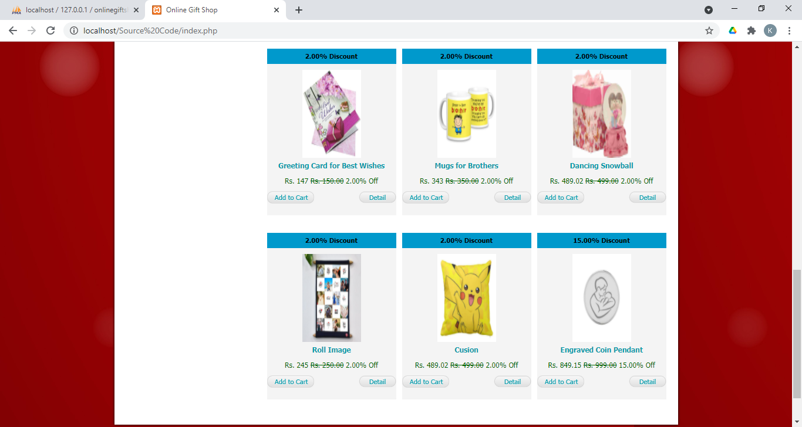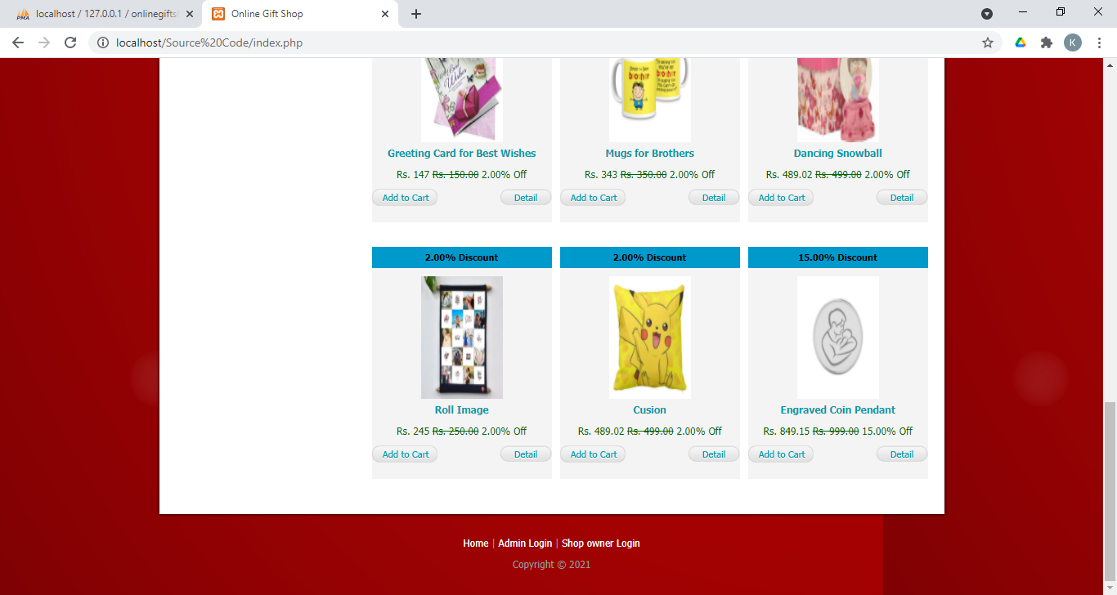

* **Customer Login Page**

Customer should enter their Email ID and Password in the Login page to place their order.

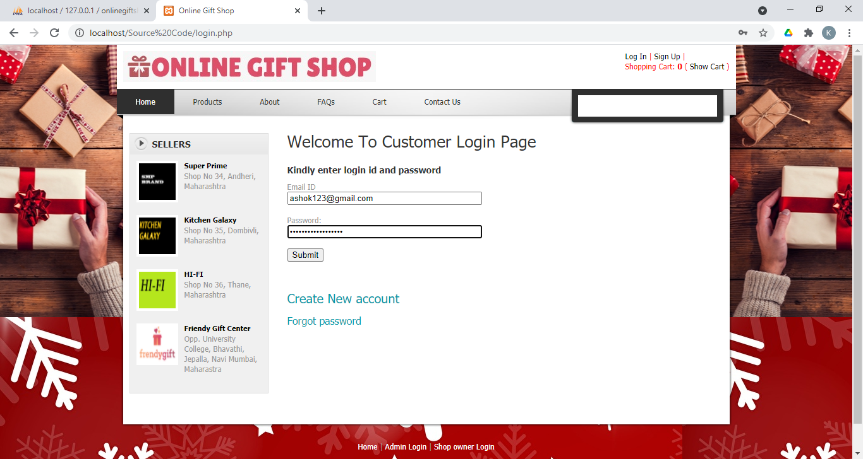

* **Customer Registration Page**

If customer doesn’t have an account in Online Gift Shop site, he/she needs to register in the customer registration page to order gifts.

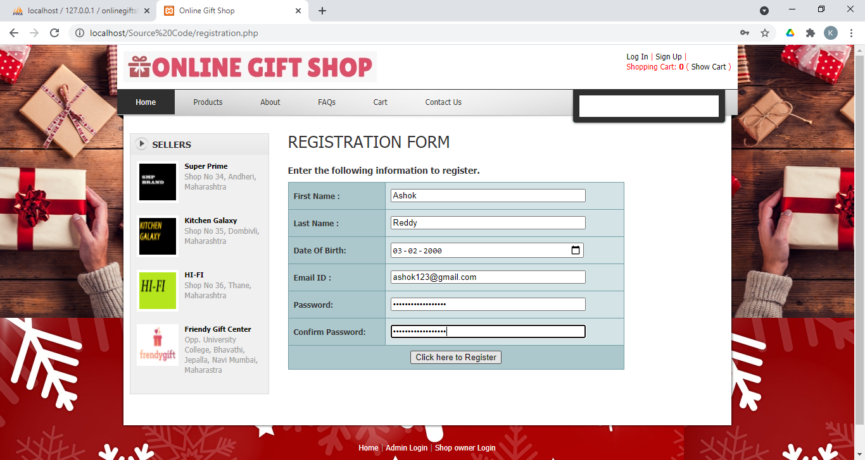

* **Customer Forgot Password Page**

If customer forgets his/her password, they can recover password in this page.

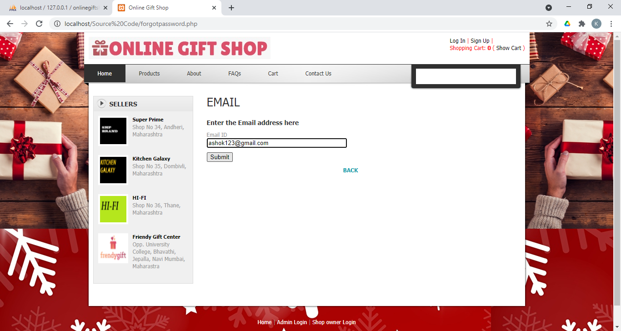

* **Products page**
* This page displays multiple products where customer can view them or select any of them to place their order.
* Customer can order multiple products by entering the quantity and clicking on add to cart button.

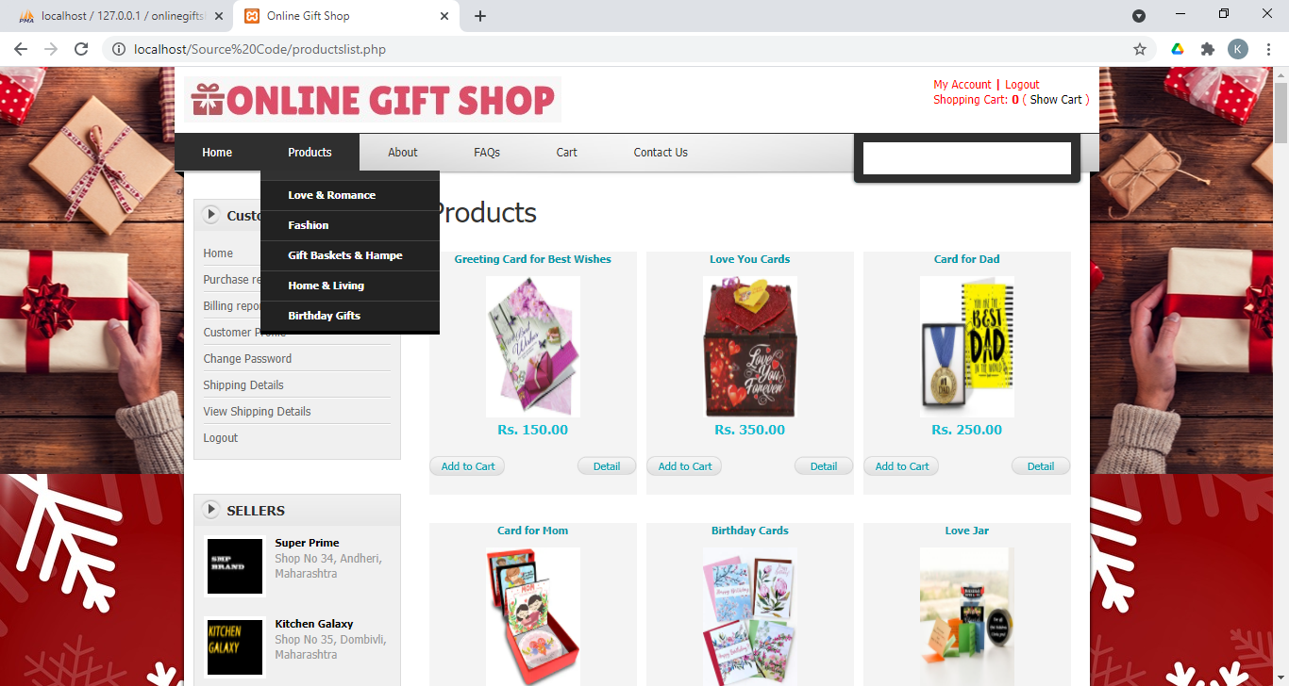

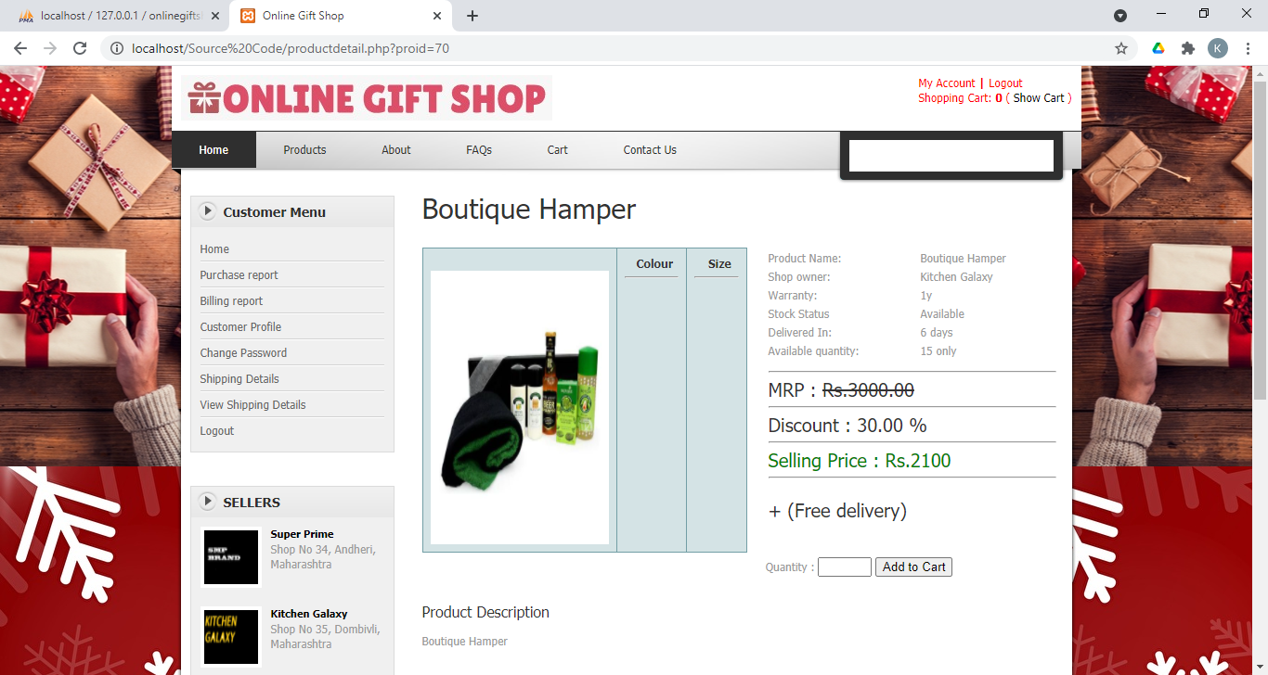

* **Customer cart page**
* This page displays products which were added to the cart by the customer.

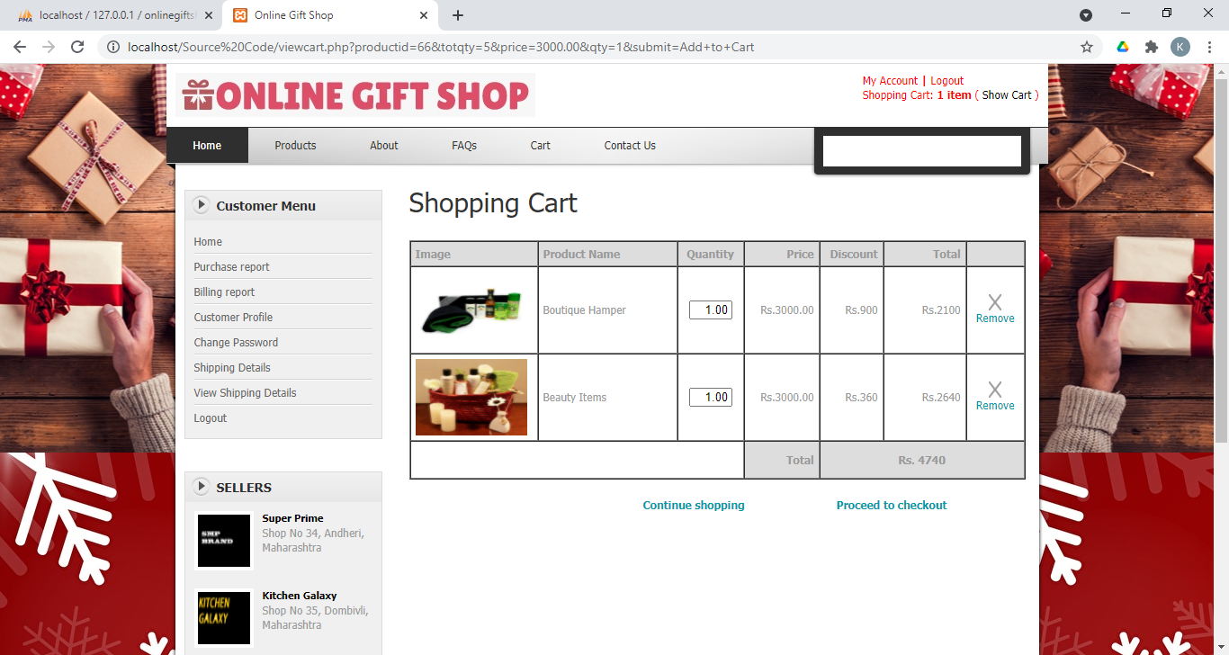

* **Customer Billing Page**

Once the products are added to the cart, it will proceed to billing page.

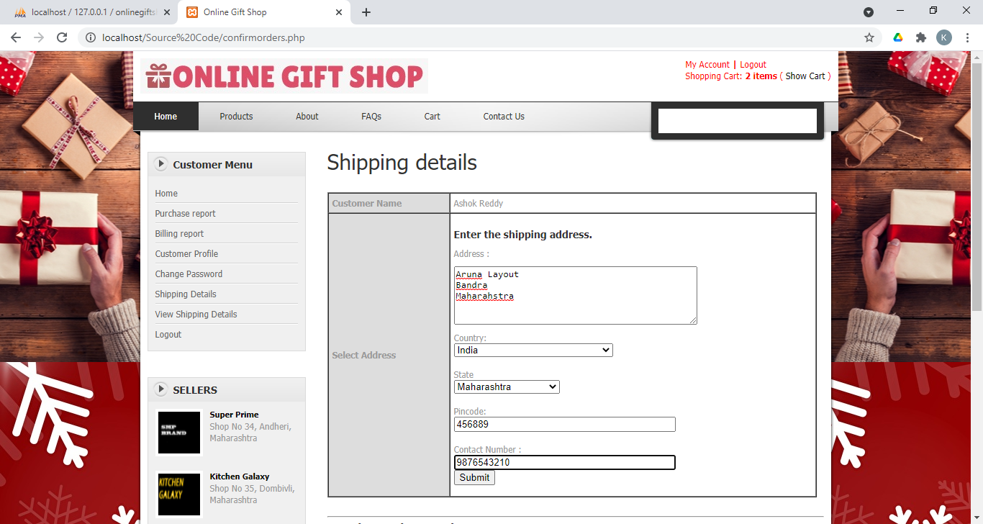

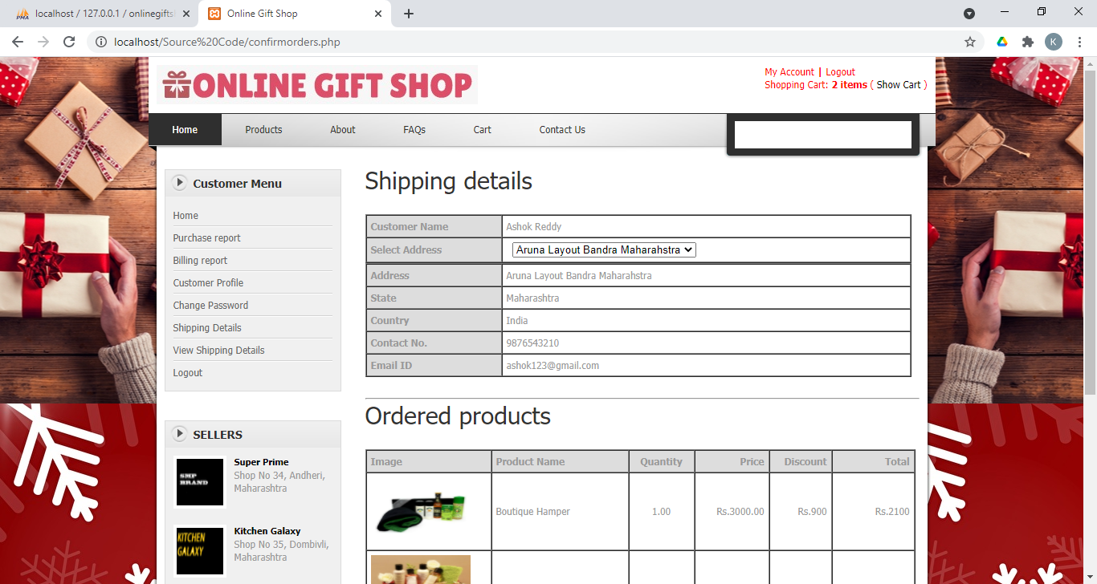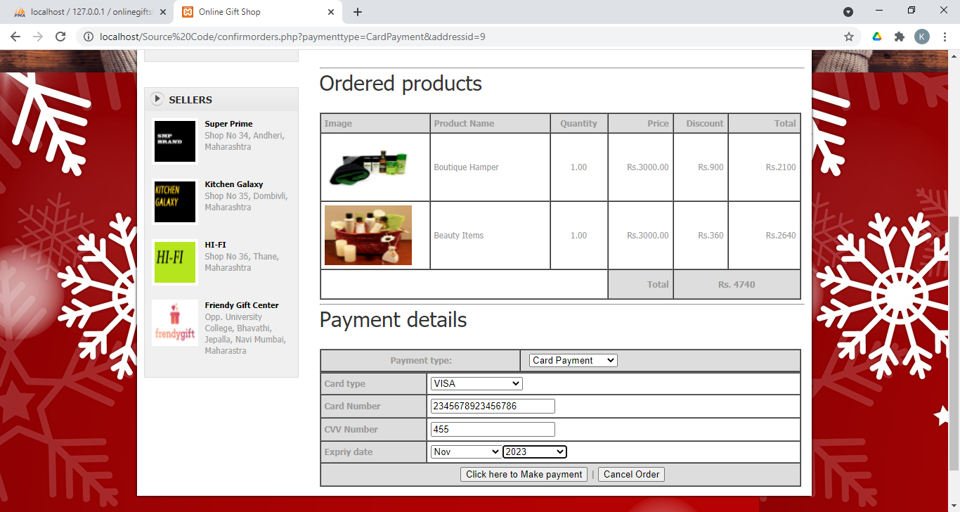

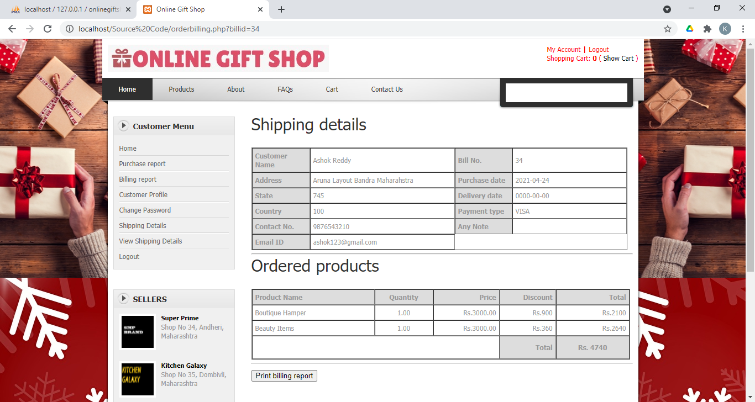

* **Add Category**

Admin can add category in the category page.

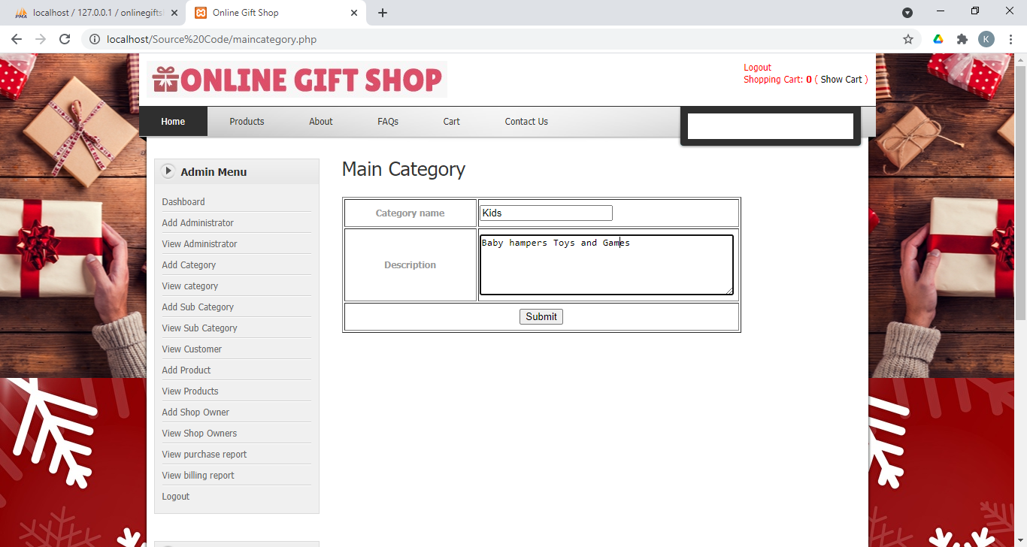

* **View Category**

Admin can view category in the category page.

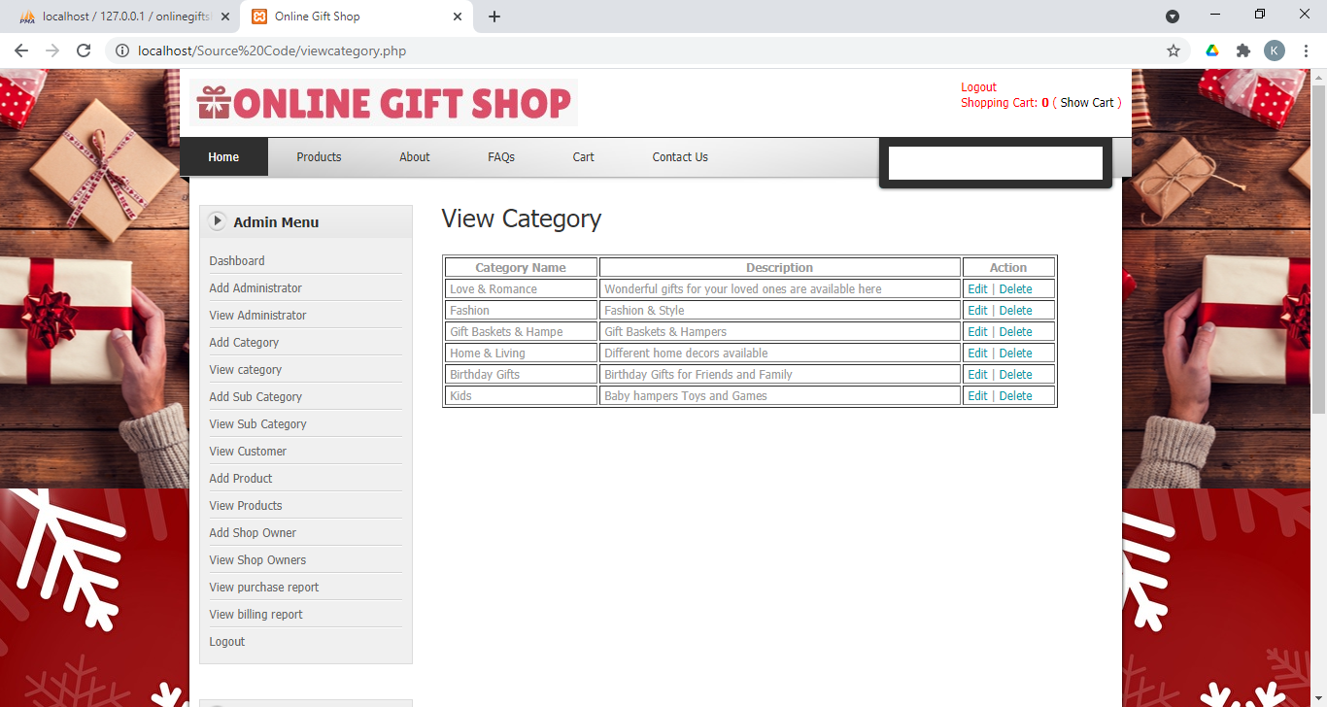

* **Add Sub Category**

In this page, Admin can add sub category by selecting the category.

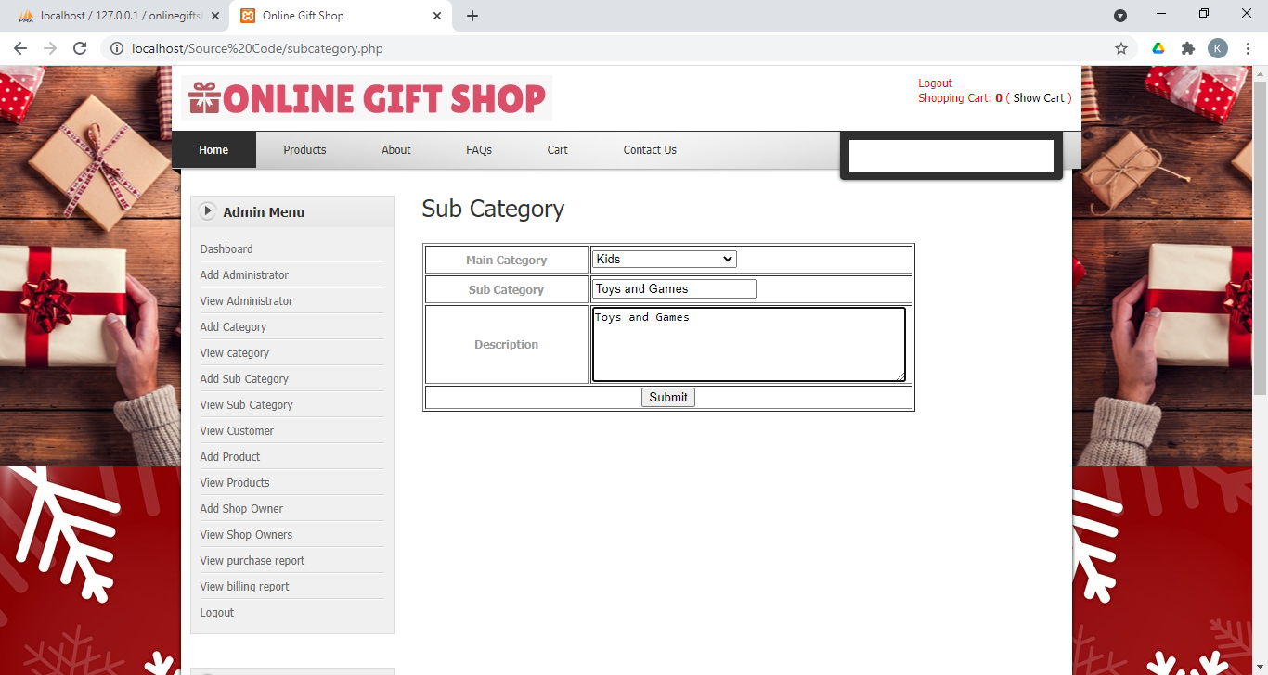

* **View Sub Category**

Admin can view sub categories in this page.

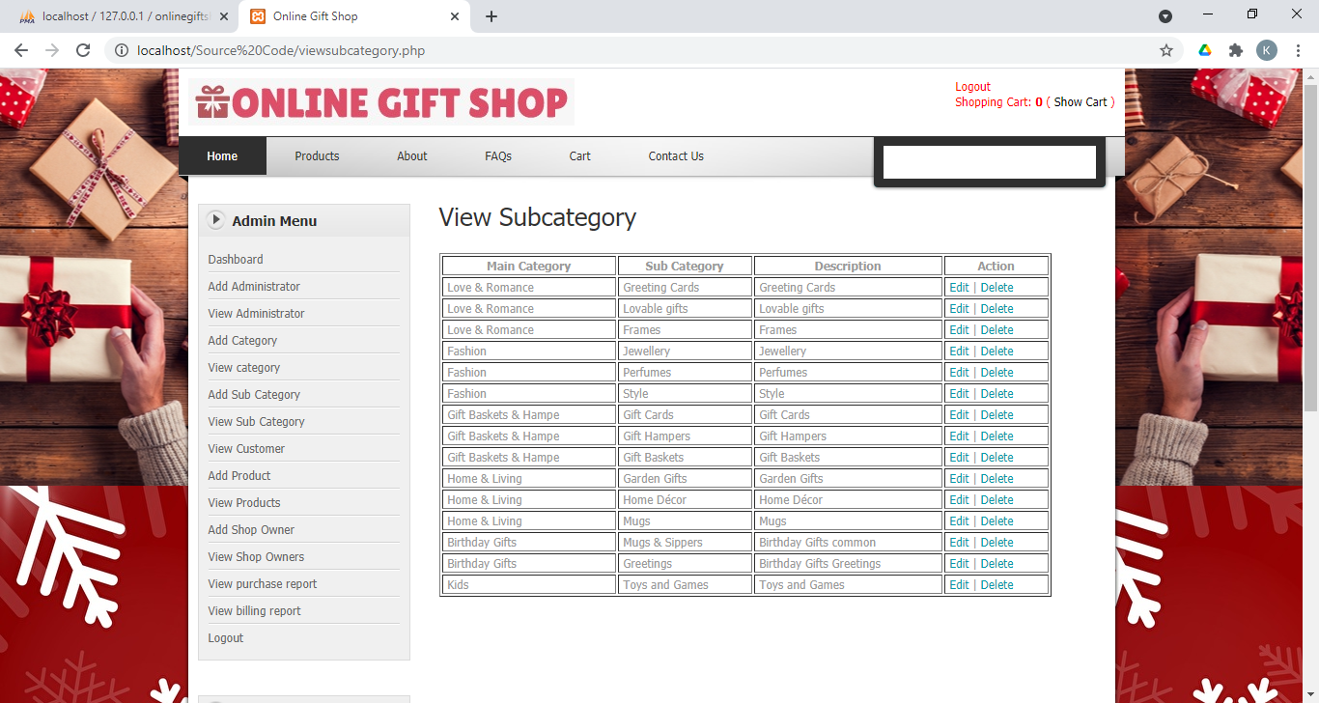

* **Add Products**

Admin and the shop owners can add products in this page.

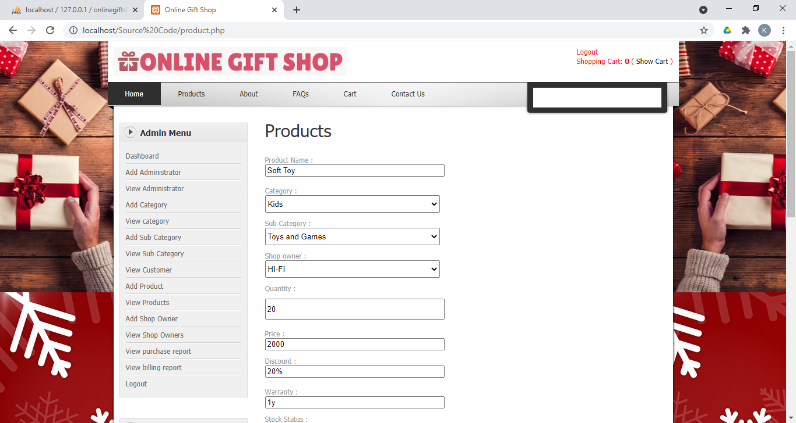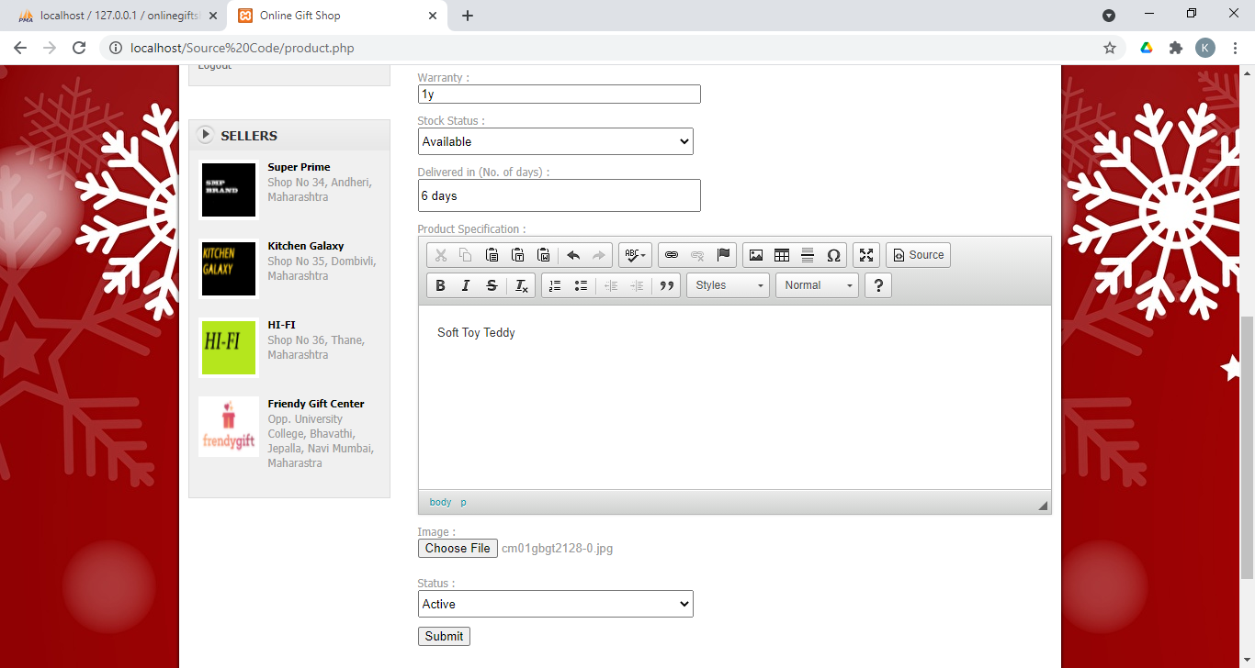

* **View Product**

Admin and the shop owners can view products in this page.

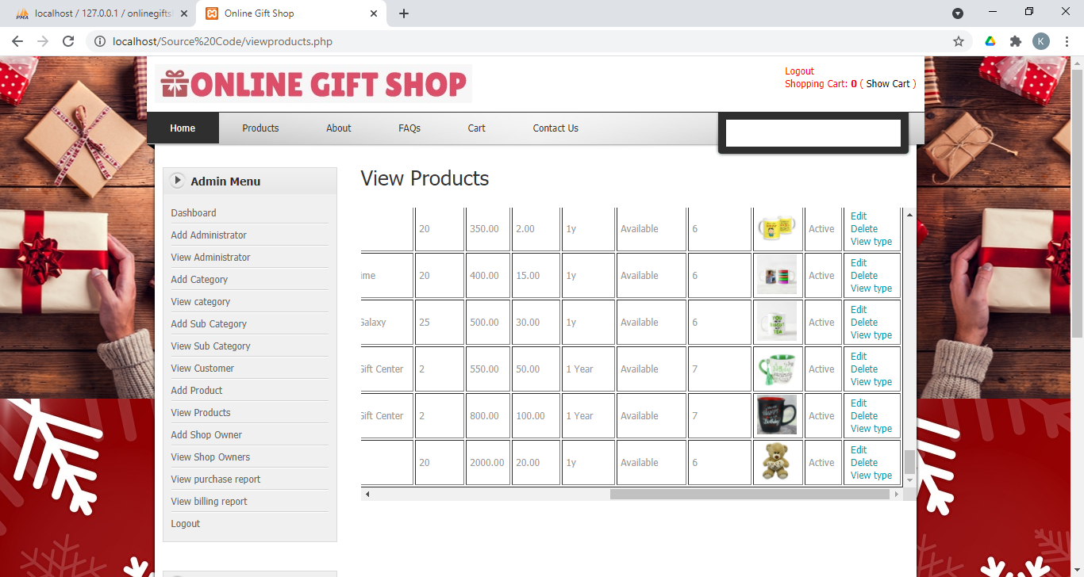

* **Billing Report**

Here Staff can view customer’s gift purchase details and payment details.

